[centos7.0 下安装jdk1.8](http://www.cnblogs.com/hz-cww/p/6084496.html)

centos7.0这里安装jdk1.8采用yum安装方式，非常简单。

1、查看yum库中jdk的版本

|  |  |
| --- | --- |
| 1 | [root@localhost ~]# yum search java|grep jdk |

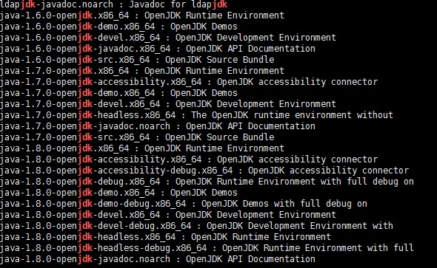

2、选择java-1.8.0安装

|  |  |
| --- | --- |
| 1 | [root@localhost ~]# yum install java-1.8.0-openjdk* |

3、配置环境变量

|  |  |
| --- | --- |
| 1 | [root@localhost ~]# vi /etc/profile |

这里jdk1.8.0的文件夹路径是/usr/lib/jvm/java-1.8.0-openjdk-1.8.0.111-1.b15.el7_2.x86_64

添加如下内容，

|  |  |
| --- | --- |
| 1  2  3  4  5  6 | #set java environment  JAVA_HOME=/usr/lib/jvm/java-1.8.0-openjdk-1.8.0.111-1.b15.el7_2.x86_64  JRE_HOME=$JAVA_HOME/jre  CLASS_PATH=.:$JAVA_HOME/lib/dt.jar:$JAVA_HOME/lib/tools.jar:$JRE_HOME/lib  PATH=$PATH:$JAVA_HOME/bin:$JRE_HOME/bin  export JAVA_HOME JRE_HOME CLASS_PATH PATH |

4、环境变量生效

|  |  |
| --- | --- |
| 1 | [root@localhost ~]# source /etc/profile |

5、查看jdk是否安装成功

|  |  |
| --- | --- |
| 1 | [root@localhost ~]# java -version |

http://images2015.cnblogs.com/blog/1052661/201611/1052661-20161121101755487-193583845.jpg

OK，jdk1.8安装搞定！